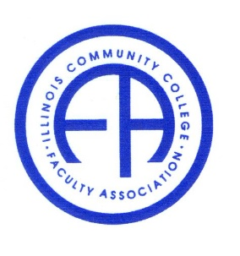
Illinois Community College Faculty Association

Friday, November 12, 2021 1:45 – 2:30 pm
Assembly Post-Conference
Via Zoom Conference

Members present: Carla Presnell, Julia DiLibert, Jake Winters and Hong Fei

- Award Nomination:
Faculty of the year nominations are still coming in. The officers will be nominated and decided in the following months. Someone other than Julia needs to step up as the conference organizer.

- Conference Postmortem
Lack of audience
Lack of organizer who are present
Technical issues came up unexpectedly due to virtual setting

The certificates are ready to be mailed.

- Concerns about the lack of support from administrators and ICCB

Faculty needs equal access to resources and reimbursement of expense. E.g. the course load release time for meetings and conference preparation.

Carla and Jake will look into IT support with pay. Julia will look into the issue of website host. Currently, we are not updating website until it is clear if ICCB will host us.

- Minutes of assembly from the last conference in 2019

Julia implores us to approve the minutes. Everyone voted yes. Minutes is approved.

- Adjourned.

