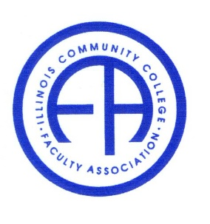
Illinois Community College Faculty Association

Friday, August 27, 2021 1:00 – 2:30 pm
Via Zoom Conference

Members present: Leo Welch, Jake Winters, Julia DiLibert, Parul Raval and Hong Fei

- Call to convene.

- Greetings, share what we did in the summer.

- President’s Report by Julia:

- Our new website has been created by Julia in response to recent disrupted server hosting of ICCB and ICCB’s desire to have us independent. The website is as the following. https://iccfa48.wixsite.com/iccfa-site
Congratulations to Julia for having single handedly created our new home. Julia asked everyone to look through it and give suggestions. Particularly she asked us to fill in on tabs connecting to statements for various issues, such as pandemic safety, dual credit, early childhood programs, diversity. They are currently empty.

- Discuss the problem with the November conference which experienced too few numbers of proposals. Discussion generated ideas including postponing to February, to April, to May, and making it an online poster session. In the end, the consensus was to tentatively postpone it to April. Julia stressed that we need to hold the meeting also because the assembly has to approve new official positions.

- ICCB Liaison Report by Melvin Harrison:

The adoption of the Strategic Plan for Higher Education is delayed. ICCB will wait until the finish of the legislative session. It will incorporate items in the session, and it will be done this summer. It is still open for review and is still taking feedbacks.

From June 14, ICCB will be back to work half time as part of the back-to-normal process. Will be 100% schedule from August with virtual Fridays.

The board meeting will be in person on June 4 in Bloomington. ICCFA will not participate this time. Melvin will summarize it for us at the next meeting.

Julia asks if we can use ICCB email address for the conference registration. Melvin agreed.

- Treasurer’s Report and Scholarship Committee Report by Carla via Julia:

The only difference in our bank account is the payout to a grand winner from a year before who didn’t get his check, Mahesh K Gurung from CCC, of $2487.60.

Scholarship still has one application and one recommendation. The deadline is September 15. It is extended to October 1.

- Secretary’s Report by Fei:

We will exam the May minutes at the next meeting because we only have 5 participants this time.

- Legislative Report by Leo:

- IBHE and ICCB recommended that faculty and students wear masks and be vaccinated. The recommendation went to all institutions. There is no action yet on these recommendations.

- Leo moves to go to an executive session the contents of which will not be for public consumption. Julia seconded and all voted to approve. Motion carries.

Leo moves to have ICCFA support the Governor’s Cov19 mandate. Debate ensued. Julia seconded. All voted to approve. Motion carries.
Julia moves to stay over with Leo to write a brief explanation for the reason to support the Governor’s initiative. All seconded.

- Adjourned.

