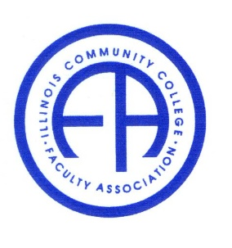
Illinois Community College Faculty Association

Friday, July 8, 2022, 10:00 – 11:00 am
Via Zoom Conference

Members present: Carla Presnell, Julia DiLibert, Seref Onders, Laura Anderson, Susan Johnson and Hong Fei

- Call to convene.

- Meet and Greet:
Members introduced self.

New members asked questions about the nature and function of ICCFA:

Q: How to collect faculty input in order to communicate to the state board?
A: Some colleges have faculty forums in the form of email group or discussion board.

Q: What are some of the functions of ICCFA? What has this committee accomplished?
A: 1) We are at the ICCB meetings. We developed working relationship with board members and administrators. We tried hard to have our voice heard. We use ways such as making statements, endorse or oppose legislative bills, or debate issues at the discussion panels at the annual conference with administrators. 2) We are funded by dues paid by colleges and give back to faculty and students through scholarships and faculty grants. 3) Our conference fills need for professional development which is required by particular hours by many colleges.

- Treasurer’s Report and Scholarship Committee Report by Carla:

The balance is at $84000 level. But this balance has not included the payout for the grants which will be $7500.

Some expenditure explained, but all routine. There is not a lot of account activities. List of due paid by colleges were shown.

Conference budget is $10,000, speaker fee $1500, scholarship $7500, travel $4000. We saved PBK sponsorship, meals expenses and retreat fees last year.

The deadline for the scholarship is postponed.

- Julia at the ICCB Meeting:

The new chair asked what they can do to help faculty – a very nice gesture. Paid leave was once again being requested. We hope to be treated as the administrators and the trustee. Full time faculty needs a Friday off or one course relive for the ICCFA business.

- Adjourned.

